Project Plan

CS 257

**About the Data Set**

The data set we chose is about the marijuana vendors in Washington from July in 2015 till now. This data set includes each of the marijuana vendors’ trade ID, vendor status, license number, trade name, total sale, street address, city, zip code, vendor type and exact location (latitude and longitude). We obtained this data set from <https://catalog.data.gov/dataset/marijuanavendor-list-5296c>. As stated in the screenshot below, this data set is intended for public access and use. Therefore, we are allowed to use this data for academic purposes.

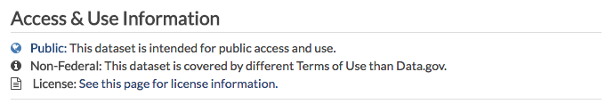

**About the Audience**

The intended audience of our application are:

1. healthcare providers in Washington who are interested in finding all marijuana retailers in their cities for medical treatments;
2. college students who are working on a case study about the contribution of marijuana business to the economy of each city in Washington, and need to know the total sale of marijuana in each chosen city;
3. Washington police officers who would like to know the precise locations of local legal marijuana trades, whereby effectively distinguishing illegal marijuana business in their region;
4. local residents in the Washington cities who would like to know the number of marijuana retailers in their neighborhoods, to assess whether this neighborhood is suitable for their children’s development.

**Functional Requirements**

Below are the functional requirements which support our audience’s goals.

**For all audience:**

1. The system must determine if a search term is in the database.
2. The system must display at least one corresponding marijuana vendor’s information (trade ID, vendor status, license number, trade name, street address, city, zip, vendor type and exact location in terms of latitude and longitude) when a search term is found in the database.
3. The system must return an error message when a user’s search doesn’t match anything in the database.
4. The system must deliver a map indicating the location of the vendor found by a search.

**For audience (2) in particular:**

1. The system must correctly calculate the total sale of marijuana in a specified city in our database.

**For audience (4) in particular:**

1. The system must correctly count the total number of marijuana vendors in a specified city.
2. The system must correctly count the total number of marijuana vendors corresponding to a specified zip code.

**For audience (1), (3) and (4) in particular:**

1. The system must deliver a map highlighting the locations of all the vendors corresponding to a specified zip code.

**Non-functional Requirements**

Below are the non-functional requirements of our application:

1. The system should be able to retrieve all information related to a data point within 0.5 seconds.
2. The system should be able to support up to 50 simultaneous users,
3. The system should be easy to use for most people with colorblindness.
4. The database in the system should not be edited by any users.

**Prioritized Key Features**

Here is our list of features ordered from the most important to the least important.

1. Our application will suggest feasible search terms according to what the users have already typed to reduce invalid searches.
2. The maps displayed by our system will user interactions such as scrolling, dragging and zooming.
3. When requested, our application will juxtapose data such as total sales of and the total numbers of marijuana vendors in any two specified cities.
4. Our application will support browsing by tabbing.
5. Our application will support sharing data on social media and via email.